Social Media Plan July 17 – July 23

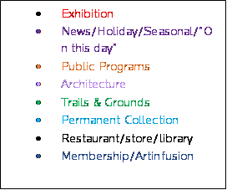

Monday July 17:

* Twitter: Reminder to post for the third round of #cbcontest
* FB: Artinfusions Insight reminder
* Instagram: Afrique Aya Concert on Thursday

Tuesday July 18:

* Insta/Twitter: The museum is closed, but grounds are open
* FB: Tomorrow before noon is the last time to enter #cbcontest

Wednesday July 19:

* FB: Tomorrow is the Afrique Aya Family Fun concert
* Instagram: #cbcontest round 3 of five photos goes live for voting
* Twitter: reminder to enter in the morning/ reminder to vote after photos go live in the afternoon

Thursday July 20:

* FB/Twitter: Afrique Aya Family Fun Concert tonight
* Insta: Guest Photo-share

Friday July 21:

* Insta: Winner of the #cbcontest
* Twitter: reminder to vote in the morning before noon/ reminder winner has been unveiled with photo in the afternoon
* Facebook:

Saturday July 22:

* Spoonerism day (Twitter/Insta? Painting of the Monkey sitting in the chair or one of Andy Warhol’s colorful animals? Explanation of what a spoonerism is)

Sunday July 23:

* Insta/Twitter: Reminder to enter the #cbcontest with photos from this weekend